Manual steps to resolve issue:
Step1:
Copy the following CLSID including brackets:
{91493442-5A91-11CF-8700-00AA0060263B}
Step2:
Now go to Start->Run->regedit it will open the registry editor window.
Step3:
Now click on root node named HKEY_CLASSES_ROOT and press ctrl+F to search for the CLSID which you copied in step1.
Note: Make sure all the check boxes should be checked while you are searching. See reference image below:
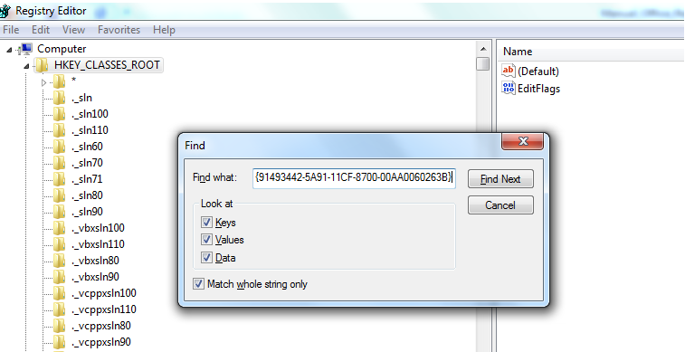
Step4:
You will get the registry entry with CLSID {91493442-5A91-11CF-8700-00AA0060263B}
Expand this CLSID you will see a sub registry entry named TypeLib. See Reference image below:
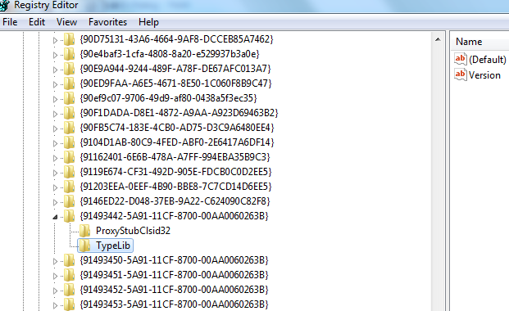
Click on TypeLib and on right side you will see default key entry which will be another CLSID. You can copy this CLSID now for next step. See reference image below:

Step5:
Now Under the root node named HKEY_CLASSES_ROOT, navigate to the registry entry named TypeLib. See reference image below:
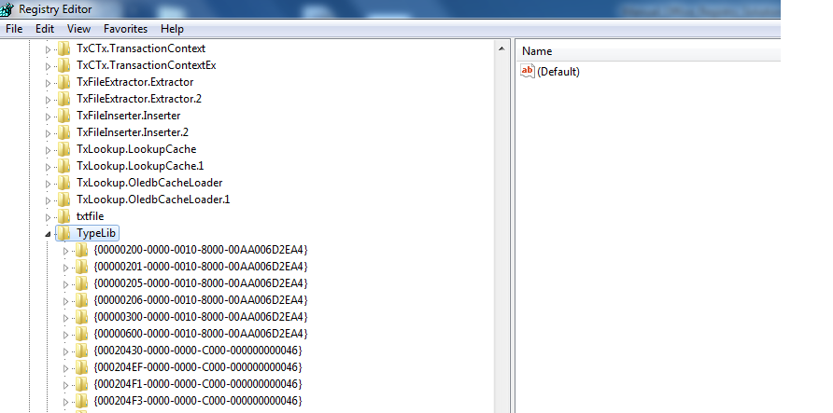
Click on the TypeLib folder and then press Ctrl+F to find the other CLSID key which you copied in step 4.
Step6:
Once you find the CLSID, Simply delete the whole CLSID. See reference image below:
